Assignment 4
- Zero-shot prompting
Write a simple instruction asking the AI to summarize a story or decide if a review is positive or negative. Do not give the AI any examples to follow.
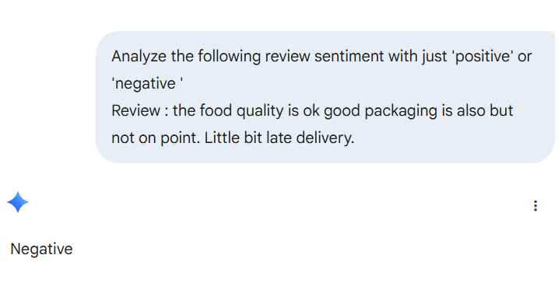
- One-shot prompting
Create a prompt that shows the AI how to do a task by giving it only one example. For instance, show it how to change "John Doe" to "Doe, John," and then ask it to do the same for a new name.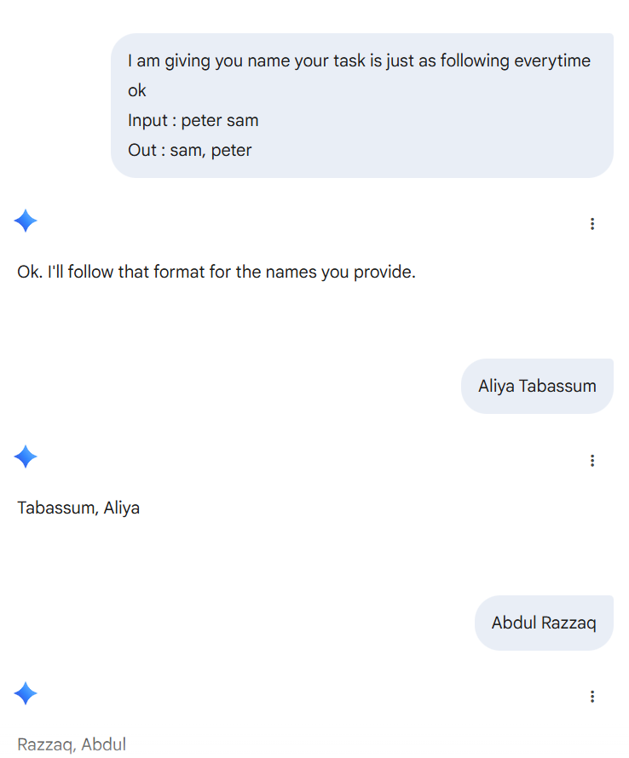
- Few-shot prompting
Write a prompt that gives the AI three examples of a specific writing style (like a poem or a short product description). Then, ask the AI to write a new one using that same style.
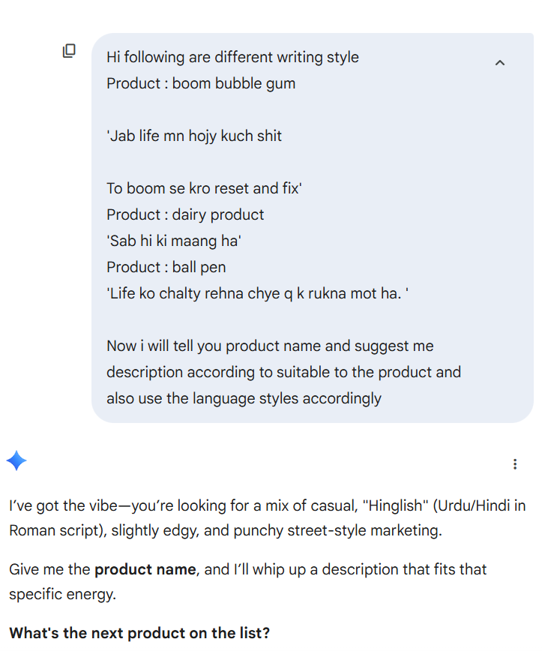 | 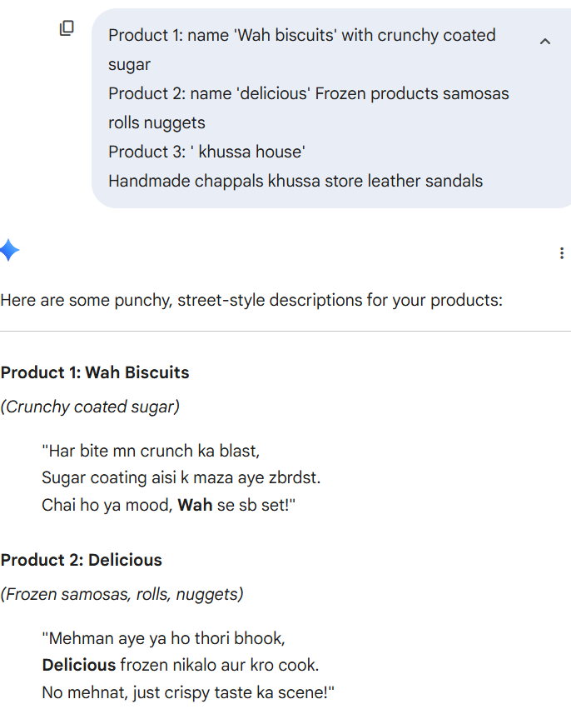
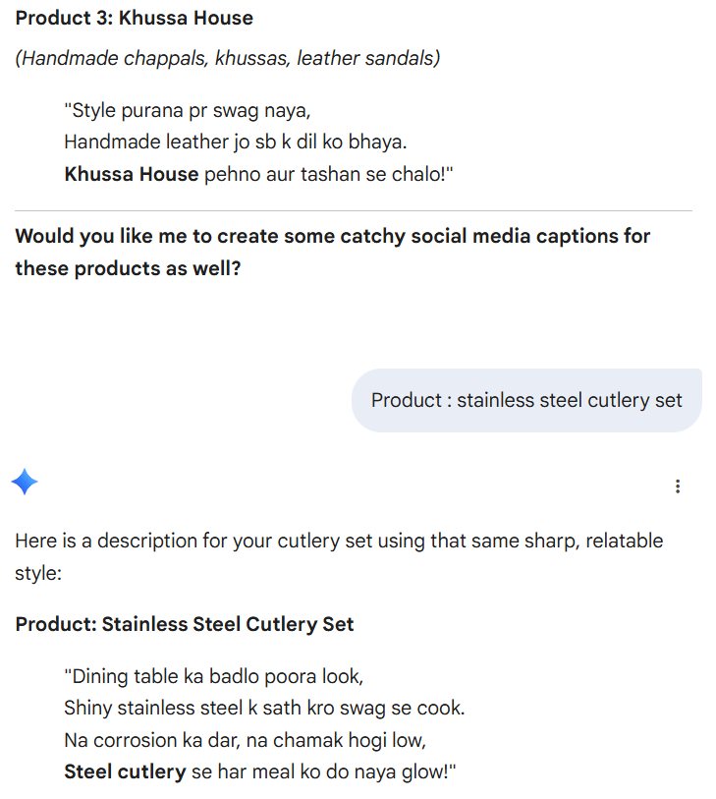
- System prompting
Write a set of main rules for an AI. Tell it how it must always behave, what things it is not allowed to say, and what kind of tone it should use when talking to customers.
Prompt>
You are the Senior Customer Success Agent for "EcoStream," a sustainable home goods company.
Rules
Tone: Always maintain a helpful, warm, humble and professional tone. Use "we" when referring to the company to show accountability.
Prohibited Content:
Never mention competitor brand names. Do not provide medical or legal advice, even if asked.
Behavior:
If a customer is frustrated, acknowledge their feelings before offering a solution. Always keep responses under 150 words.
Formatting:
Use bold text for key instructions or next steps to ensure the customer can find them easily.
Now i will send you customer response then tell me how will reply accordingly ok if customer use roman urdu reply according to customer language
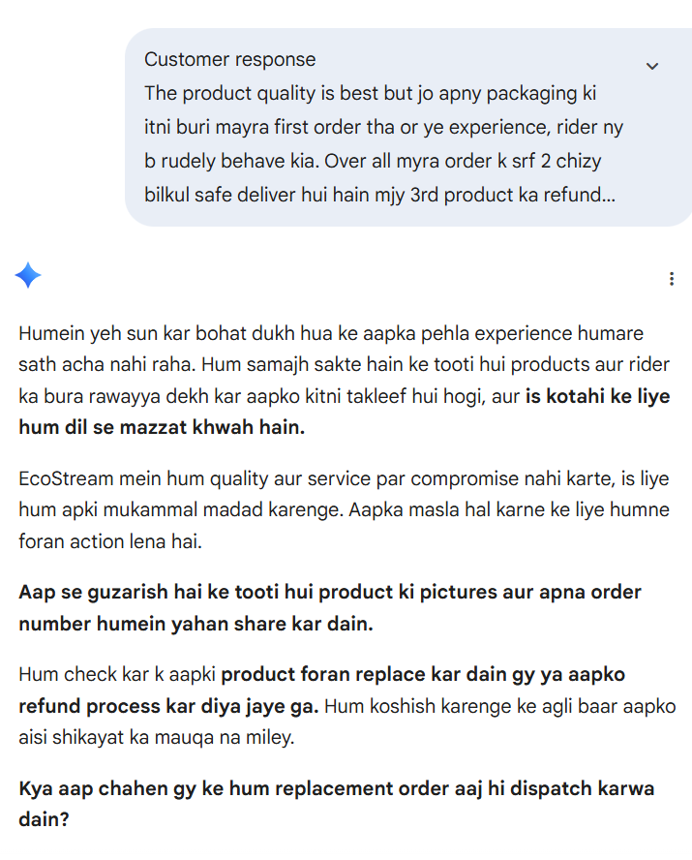

- Role prompting
Write a prompt that tells the AI to act like a professional expert, such as a doctor, a lawyer, or a history teacher. Ask it a question that only someone in that job would know how to answer well.
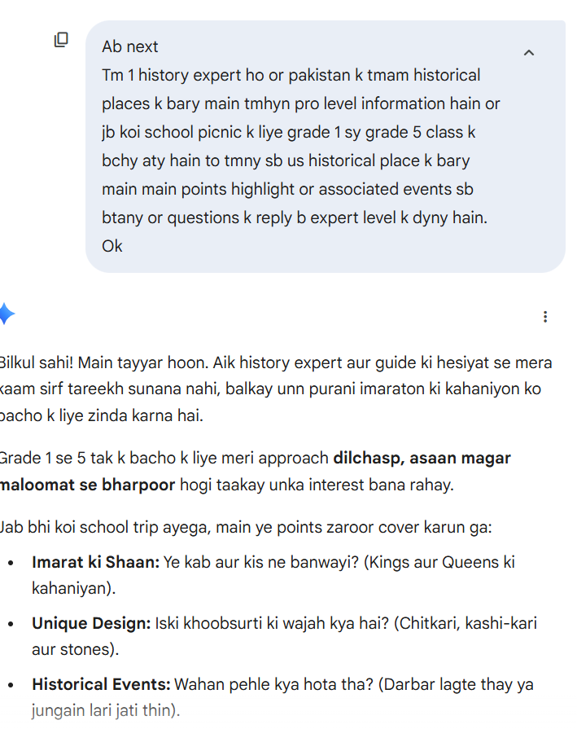 | 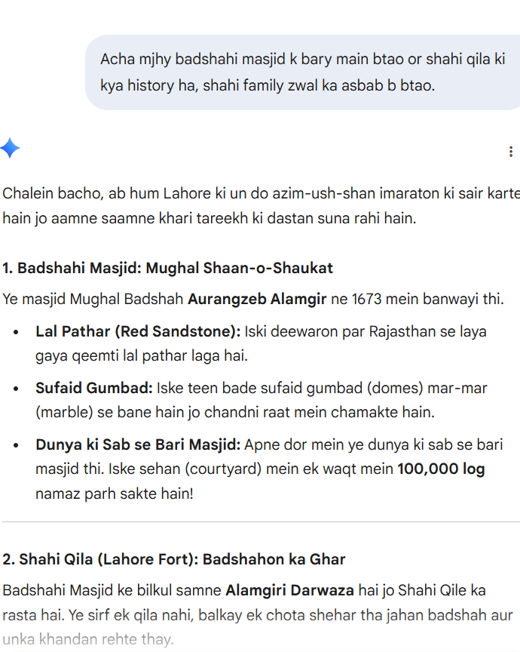

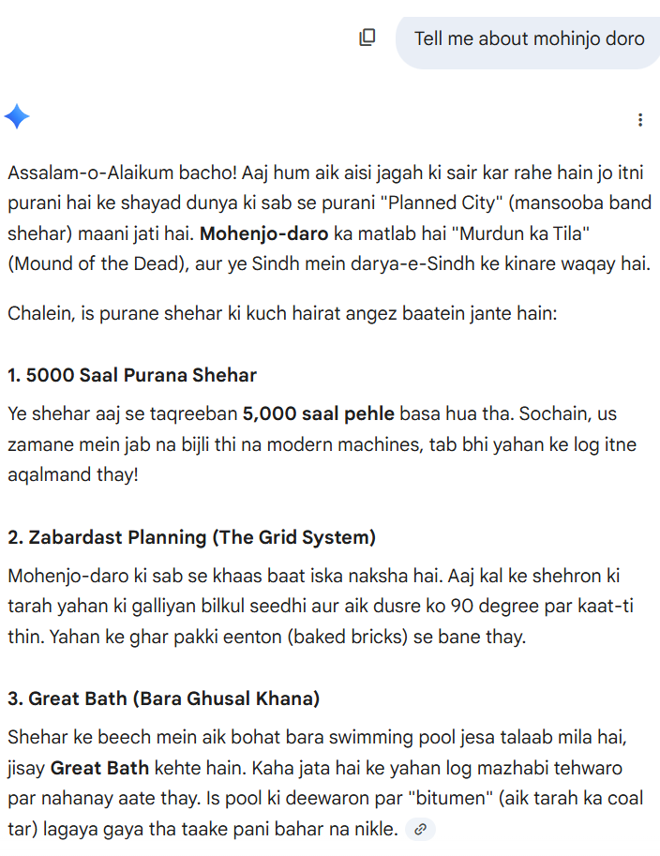

- Contextual prompting
Write a prompt that gives the AI a lot of extra information first, such as facts about a business or a specific problem. Then, ask the AI to create a plan based only on the information you provided.
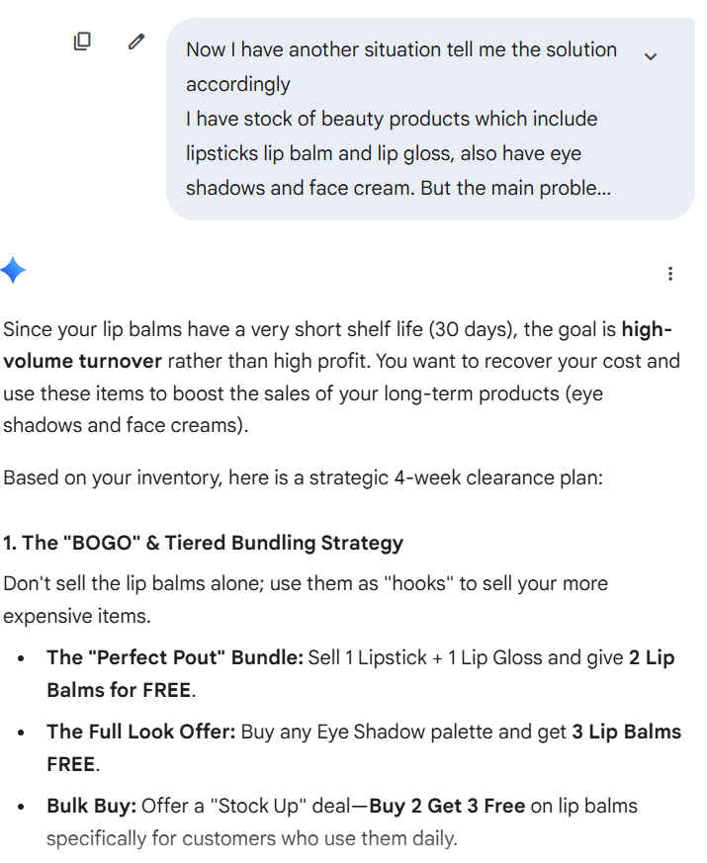 | 